Say Goodbye to Tight Hips With These Yoga Poses
March 31, 2014
Do you have tight hips from spending hours a day sitting at desk? These five yoga poses to improve your flexibility, reduce stress and tension, and help alleviate low-back pain. These poses stretch the key muscles that flex the hips and will leave you feeling oh so good after a long workday.
Low Lunge With Quadriceps Stretch (Anjaneyasana variation)
Place a folded blanket or towel over your mat and position it near a wall. From a high kneeling position, step the right foot forward toward the front edge of the mat. Shift your weight forward, deepening the bend in the front leg as you allow the right thigh to draw parallel to the floor; be sure to keep the right knee tracking in line with the second toe. Maintain this low lunge position as you bend the back knee, drawing the heel up toward your seat. If accessible, reach the left hand back behind you to grasp the top of the left foot or place the left toes against the wall behind you to facilitate the stretch. Breathe deeply as you hold this pose for 30 to 60 seconds before repeating on the opposite side

Lizard (Utthan Pristhasana)
Begin in downward facing dog position and step the right foot between the hands to come into a low lunge position; shift forward slightly to allow the right thigh to draw parallel to the floor and the left knee and shin to connect to the mat. As an option, place a folded towel or blanket underneath the left knee for additional support. From this position, bring both hands to the inside of the right foot, releasing the elbows and forearms to rest on a block, a folded blanket or the mat, depending on which option is most accessible for you. Keep your hips and shoulders squared to the floor as you breathe deeply in this pose, holding for 30 to 60 seconds before repeating on the opposite side.

Bound Angle (Baddha Konasana)
Begin in a comfortable seated position with knees bent and feet flat on the floor. Maintain an extended spine as you bring the soles of the feet together and the knees release away from one another toward opposite sides of the mat. Place the hands on the tops of the feet and gently guide the heels in as close to the groin as is accessible for you, keeping the outer edges of the feet in contact with the mat. Keep your spine lengthened and the core engaged as you lean forward slightly, drawing the heart toward the heels to deepen the stretch. Breathe deeply as you hold this pose for 45 to 60 seconds.
Fire Log (Agnistambhasana)
Sit comfortably in a simple cross-legged position, either directly on your mat or on the edge of a folded blanket or towel. Place your left ankle on top of your right knee, allowing the shins to stack on top of one another, and release the left knee toward the right foot. You may opt to lightly place the hands on the thighs or release the palms to the mat just outside of each knee. Breathe deeply as you hold this pose for 30 to 60 seconds before repeating on the opposite side.
Wind Relieving Pose (Eka Pada Pavanamuktasana)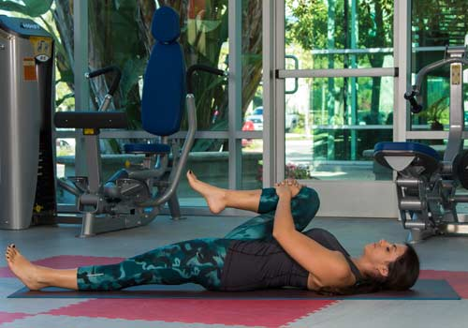
Lie on your back with the knees bent and feet on the floor. Draw your right knee in toward your chest, interlacing your fingers to rest the palms on the right shin, just below the knee. Gently guide the right knee toward the right armpit, just outside of the chest, and extend the left leg to rest fully on the mat. Breathe deeply as you hold this pose for 30 to 60 seconds before repeating on the opposite side.
By Jessica Matthews, MS, E-RYT
Jessica Matthews, M.S., E-RYT is assistant professor of exercise science at Miramar College and a subject matter expert for the American Council on Exercise (ACE). She is also a fitness blogger for Weight Watchers, Fitbie and Shape, and a regular contributor to numerous publications including CNN, USA Today, Women’s Health and Oprah.com. Jessica holds a bachelor’s degree in physical education teacher education from Coastal Carolina University, a master’s degree in physical education from Canisius College, as well as three ACE certifications (Personal Trainer, Group Fitness Instructor and Health Coach). A long-time lover of yoga, she is an Experienced Registered Yoga Teacher (E-RYT) through Yoga Alliance and a trained stand-up paddleboard (SUP) yoga instructor. Prior to her full-time position at Miramar College, Jessica served as an adjunct professor at MiraCosta College while working full-time for ACE serving in a number of roles including exercise physiologist, certification director

